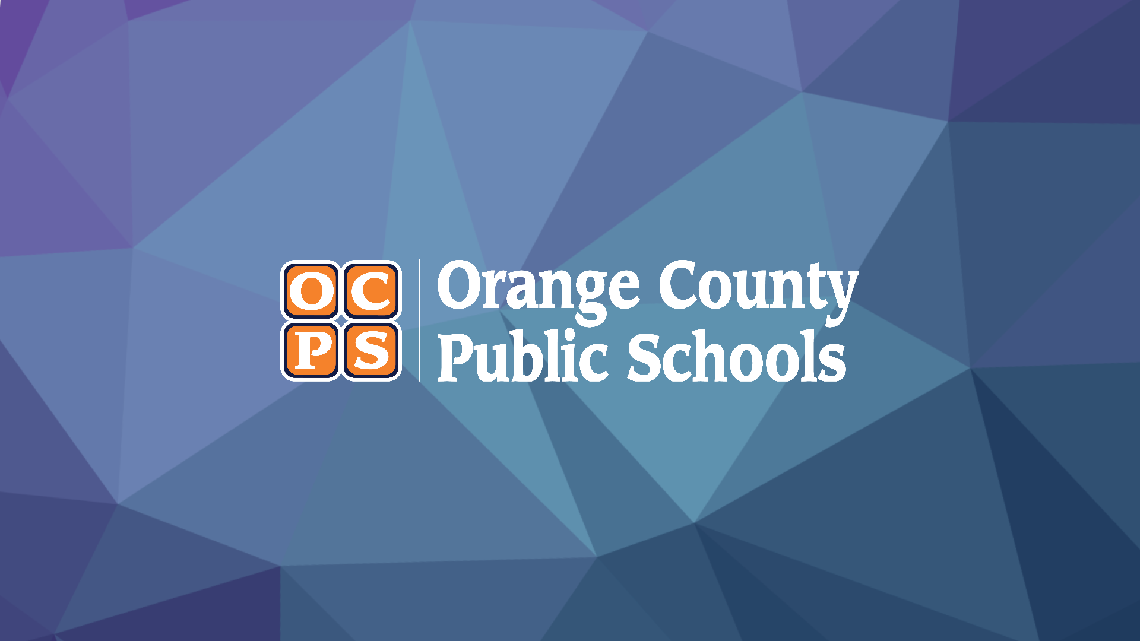

Pine Hills Elementary School

Media Center Collection Development Plan

LaTonya Smothers  Principal |  | Beth Law  Certified Educational Media Specialist

Table of Contents

Table of Contents 2
Executive Summary 3
District Strategic Plan 2025 3
School Collection Development Plan 3
School Analysis 4
Collection Analysis 5
Collection Analysis by Category 6
Representation Analysis 7
Results 7
Summary 7
Strategic Focus 8
Budget and Purchasing Plan 9
Annual Budget 2022-2023 9
Purchasing Plan 2022-2023 9

Executive Summary

District Strategic Plan 2025

Orange County Public Schools is the ninth-largest school district in the United States and the fourth largest in Florida. The district serves more than 206,000 students at 202 schools and is one of the largest employers in Central Florida with more than 25,000 team members.

Vision: To ensure every student has a promising and successful future.

Mission: With the support of families and the community, we create enriching and diverse pathways to lead our students to success.

School Collection Development Plan

Pine Hills Elementary School serves 668 students enrolled in PreK through Fifth grades. The student population’s ethnicity is made up of 13% Hispanic and 87% Non-Hispanic students. Additionally, we serve a diverse population made up of 14% White, 82% Black, 1% Native, 0% Asian, 1% Pacific, and 3% Multicultural students.

The administration includes Principal LaTonya Smothers and Assistant Principal Joshua Adkins. Pine Hills Elementary School is proud to offer programs including SSYRA Battle of the Books and science enrichment which provide students with opportunities. Pine Hills Elementary School supports its students and community by providing resources and events to enrich and educate both children and families.

A thorough analysis of the current media center collection at Pine Hills Elementary School indicates that the average age of the collection is 2014 and the number of books per student is 11. The American Association for School Libraries has established a criteria for a highly effective media center that includes a ratio of 15-20 books available per student in the collection.
At this time, Pine Hills Elementary School does not meet the recommended standards for the number of books per student.

The analysis of the collection also revealed the following areas of strengths and concerns:

- The existing collection is satisfactory in condition and overall age, but is too small for the student body.
- Based on the school-wide data, while our students improved on the state achievement tests, they are still scoring below average proficiency.
- The school is starting Accelerated Reader this year. Over 90% of our titles are AR ready, but purchasing titles that support this program should be a priority.
- Another priority is the purchasing and showcasing of emergent (RL 0-0.9) reading materials that are AR ready.

School Analysis

The school analysis provides an overview of the school’s enrollment, demographics and proficiency data.

Enrollment & Demographic Data
668  2022-23 Student Enrollment as of August 31, 2022 |  | Subgroups |  | Federal Ethnicity
 |  | 16%  ELL | 6%  ESE | 13%  Hispanic | 87%  Non-Hispanic
Federal Race Category
14%  White | 82%  Black | 1%  Native | 0%  Asian | 1%  Pacific | 3%  Multicultural
Proficiency Data
Assessment | 2020-21 | 2021-22 | Assessment | 2020-21 | 2021-22
FSA ELA  Grade 3 | 19% | 44% | FSA Math  Grade 3 | 28% | 53%
FSA ELA  Grade 4 | 17% | 29% | FSA Math  Grade 4 | 14% | 31%
FSA ELA  Grade 5 | 22% | 30% | FSA Math  Grade 5 | 21% | 16%
NGSSS Sci 5 EOC | 29% | 29%

Collection Analysis

The collection is developed for and influenced by students, their interests, academic needs and alignment to the curriculum. The data below is a snapshot of the collection based on a Titlewise Analysis.

9559  Items in the Collection |  | 14  Items per Student |  | 57%  Fiction Titles in the Collection |  | 33 %  Non-Fiction Titles in the Collection
Library media resources are curated to include both recently published works and classics that both rightfully impact the average age of the collection.
 |  | 2014  Average Age of the Collection |  | 14%  Aged Titles |  | 50%  Newer than 5 Years
Library media resources should be representative of the school. A commitment to representative literature is reflective of OCPS values such as equity, inclusion, and respect. |  |  |  | Social-Emotional Learning (SEL) library media resources can contribute to the development of character and social-emotional skills, one of the OCPS’s key performance indicators.
40%  Representative Titles  in Collection |  | 2014  Representative Titles  Average Age |  | 47%  SEL Titles in Collection |  | 2014  SEL Titles Average Age
Library media resources are distributed across the lexile reading level ranges noted below.
 | 121 | 344 | 1019 | 2320 | 1800 | 427 | 2
 | BR-199 Lexile Items | 200-349  Lexile Items | 350-499  Lexile Items | 500-674  Lexile Items | 675-909  Lexile Items | 910-1299  Lexile Items | 1300+  Lexile Items

Collection Analysis by Category

The information collected in this section provides a detailed look at the current library collection by classification and genre. The information was gathered from Follett Destiny, the library management system, and Titlewave, the vendor’s ordering and analysis tool.

Section | # of Titles | Average Age
Computer Science, Information & General Works | 30 | 2017
Philosophy & Psychology | 64 | 2014
Religion | 11 | 2017
Social Sciences | 470 | 2013
Language | 0 | 0
Science | 512 | 2016
Technology | 253 | 2016
Arts & Recreation | 139 | 2017
Literature | 32 | 2012
History & Geography | 432 | 2015
Biography | 432 | 2017
Easy | 2039 | 2012
General Fiction | 2169 | 2015
Graphic Novels | 616 | 2016

Notes
- Overall, the collection is up to date.
- The collection is strong in biography and social sciences.
- The collection is weak in language and literature.
- The collection is becoming outdated in technology and science topics.
- The number of items in arts and recreation topics (extremely popular) is low and becoming outdated.

Representation Analysis

To deepen focus on strategic collection development, specific sections of the collection were analyzed in detail to determine whether the media center collection reflects and represents various points of view and experiences. The goal is to provide a balanced collection that can be both a mirror, to reflect a reader's experience, and a window, so readers can experience different viewpoints.

Results

Based on the available school data of Pine Hills Elementary School in comparison to Collection Analysis results, it was found that:

Representation Focus | Avg. Age of Target Population Titles | # of Target Population Titles | % of Target Population Titles | % of Students
African American | 2015 | 909 | 10.5% | 82%
Emergent Readers (below | 2012 | 121 | 1% | 63%

Summary

After completing a deeper, targeted analysis of the representation section of the TitleWise report, it was determined that:

- Books that support the Accelerated Reader program will be targeted overall.
- Supporting emergent and struggling readers will be a top priority.
- African American, Haitian Creole and Hispanic inclusive titles will be included.
- As in past years, books that support programs such as SSYRA and SSYRA Jr. will be purchased.

Strategic Focus

This page lists the priorities for selection and weeding for each school year and includes the action, updates, and outcomes. This is subject to change due to funding and time constraints.

School Year | Strategic Focus
2022-23 | Selection Priorities  - Emergent Readers (Level 0-1.0)  - Technology, Computer, and Science books  - Sports  - Fine Arts (Art, Music, Poetry)
Weeding Priorities
- Outdated 000’s
- Outdated 500’s
- Outdated 600’s
- Outdated 700’s

2023-24 | Selection Priorities  - Graphic Novels  - History and Geography  - TBD
Weeding Priorities
- Outdated 900’s
- Outdated Biographies

Budget and Purchasing Plan

This page outlines the current budget available and specifically lists the priorities for this school year (2022-2023).

Annual Budget 2022-2023

State Funds
Source | Amount
State (10011111000) | $13,618.48
Internal Accounts
Source | Amount
Book Fairs | 500.00
Other | 0
TOTAL | 14,118.48

Purchasing Plan 2022-2023

Approximate Purchasing Plan
Purpose | Amount
Emergent Readers (RL 0-1.0 and 1.0-1.9) | 4,000.00
Sunshine State books | 2,000.00
Technology, Computer and Science | 3,000.00
Sports and Fine Arts | 2,000.00
 | 3,118.48
TOTAL | 14,118.48

Reviewed by Stakeholders on DATE ________________________________________________

